IC-02 Measurement Instruments
Rev 1-24-2024

2.1 OBJECTIVES
a. To understand how to use measurement devices to measure length and mass.
b. Determine the densities of Regular Solids (cylinders, rectangular prism), an irregular shaped solid and a copper wire, by finding their volumes and masses. Identify the materials by comparison of densities with the accepted values.

2.2 EQUIPMENT
1. Triple- beam balance 2. Electronic balance 3. Micrometer
4. Vernier Caliper 5. A ruler 6. Graduated Cylinder
7. Overflow Can 8. A roll of copper wire 9. Wire Cutter
10. An Irregular object 11. A rectangular solid 12. Three Regular Cylinders
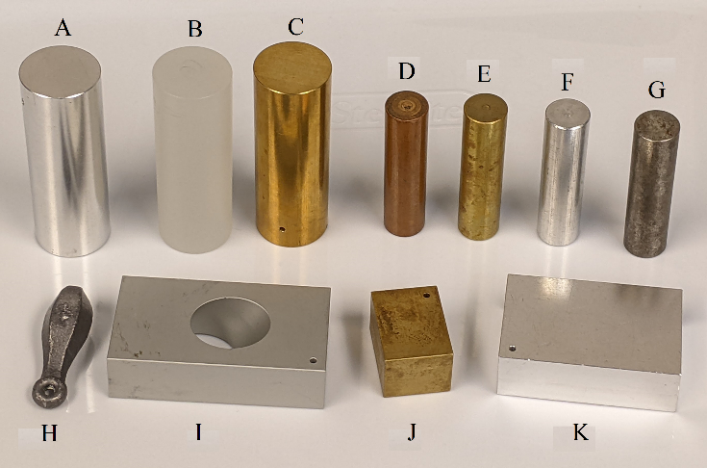
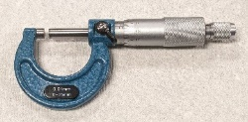
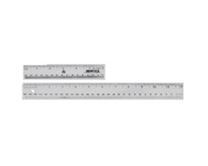
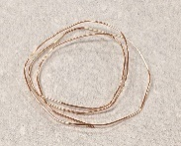
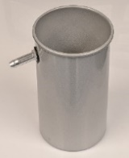
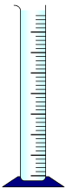

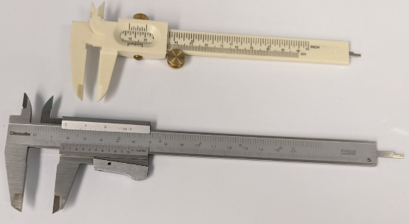
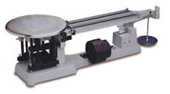
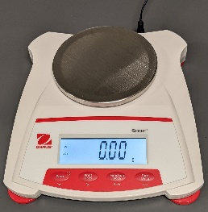

2.3 THEORY
Physics is a science of measurement that involves measurements of various parameters. Therefore, we need to learn how to take accurate measurements and how to use these numbers for calculations. In any measurement the uncertainty associated with it and the number of significant figures should be of particular interest to the experimenter. It should be underlined that the number of significant figures to be kept in a reading depends on the measuring device used. In this experiment the dimensions of various objects will be determined by means of a meter ruler, a Vernier caliper, and a micrometer caliper and the probable error in these measurements will be determined. The mass of each object will be measured with a triple beam balance (or electronic balance if available) and the density of each object as well as the material from which it is made will be determined.
Density is the measure of the compactness of matter in a substance. This might be done experimentally by measuring the mass and obtaining the volume of the substance. The volume may be obtained in different ways depending on the shape of the substance. For example, for regular solids we can use equations to determine the volume, while in the case of an irregularly shaped object, its volume may be determined by submerging object in water contained in a graduated cylinder. Usually, an object displaces its own volume of water hence the difference in the cylinder reading before and after the immersion gives the volume of the object.
Density denoted by a Greek alphabet, ρ, is usually expressed in g/cm³ or kg/m³, and sometimes in lb/ft³. Density is one of the useful quantities’ scientists use to identify different materials with.
The following formulae would be useful in calculating the densities of regular shaped objects.

Density: $ρ= \frac{Mass}{Volume}$
Volume of a cylinder: $V= πr^{2}h$ or $V= \frac{πd^{2}h}{4}$ where r = radius and h = height
Volume of a rectangular solid: V = L x W x H ( i.e. Length x Width x Height)
Volume of a sphere: $V=\frac{4}{3}πr^{3}$ (where r is the radius of the sphere)
Percent Error: $\% error=\frac{|Accepted value-Computed value|}{Accepted value}×100 (\%)$

Example 1: What is the density of a cylinder that has a mass of M = 227 g, diameter of d = 2.50 cm and length h = 6.20 cm?
$V= \frac{1}{4}πd^{2}h=\frac{πx{2.50}^{2}x6.20}{4}=30.434 {cm}^{3}$ $ρ= M/V=\frac{227}{30.434}=7.459 g/{cm}^{3}$= $7.46 g/{cm}^{3}$
In order to make precise measurements one needs to use accurate devices that will minimize the errors in our measurements.

2.4 HOW TO USE EQUIPMENT

a) Triple-Beam Balance
We use it to find the mass of each object. It consists of three beams along each one slides a weight. One beam has a notch every 100 g, the next one every 10 g and the last one every 1 g. Since this beam consists of 100 divisions equaling a mass of 10 g then this balance can read to 0.1 g and estimate to 0.05 g.

b) Vernier Caliper
A Vernier caliper is a common tool used to measure the length of an object, the outer diameter (OD) of a round or cylindrical object, the inner diameter (ID) of a pipe, and the depth of a hole. The Vernier caliper is more precise than a metric ruler because it gives an accurate measurement to within 0.01cm. and can be used to estimate to 0.001 cm.
The Vernier consists of a main scale engraved on a fixed ruler and an auxiliary Vernier scale engraved on a movable jaw. The movable auxiliary scale is free to slide along the length of the fixed ruler. In Fig. 1, the Vernier’s main scale is calibrated in centimeters and the smallest division is in millimeters. The auxiliary (Vernier) scale has 10 divisions that cover the same distance as 9 divisions on the main scale. Therefore, the length of the auxiliary scale is 9.0 mm. The Least Count of a measuring instrument is the smallest change in the measured quantity that can be resolved on the instrument's scale.
$$Least count=\frac{Smallest division on main scale}{Number of divisions on vernier scale}$$
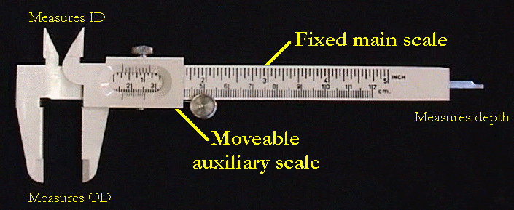
Figure 1
For the Vernier Caliper shown in Fig. 1, this comes to 0.1 cm / 10 = 0.01 cm = 0.1 mm. Once the Vernier is positioned to make a reading, the jaws are closed on the object and we make a note of where the first mark on the auxiliary scale falls on the main scale. In Figure 2, we see that the object's length is between 1.2 cm and 1.3 cm because the first auxiliary mark is between these two values on the main scale. The last digit (tenths of a millimeter) is found by noting which line on the auxiliary scale coincides with a mark on the main scale.
In our example, the last digit is 3 because the third auxiliary mark lines up with a mark on the main scale. Therefore, the length of the object is 1.23 cm.
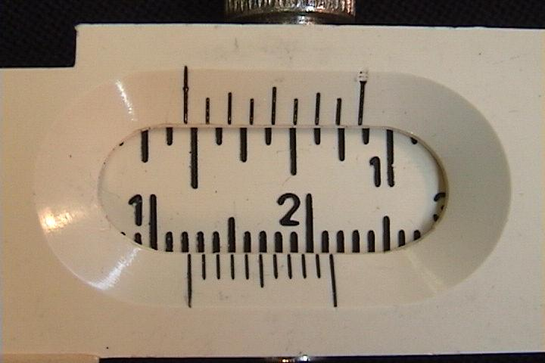
Figure 2

c) Micrometer
It is used to measure very small thicknesses and diameters of wires and spheres. It consists of a horizontal scale along a barrel divided into millimeters and a circular scale that has 50 divisions. The thimble has a scale of 50 equal divisions, each division is 0.01mm. (Figure 3). The Least count = 0.5 mm / 50 = 0.01 mm = 0.001 cm.

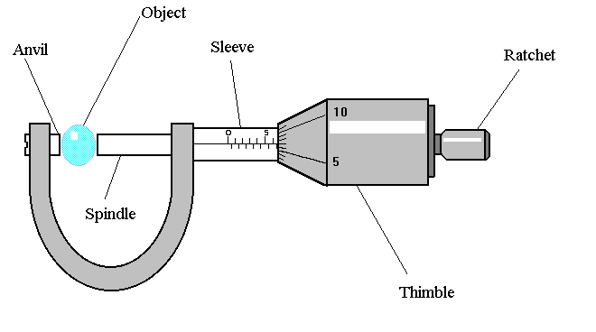
Figure 3

To take a measurement using the micrometer, place the object to be measured between the anvil and spindle. Grip the ratchet and turn until the object is lightly gripped. DO NOT OVERTIGHTEN.
The first part of the measurement is taken from the sleeve. Each division is 0.5 mm (note that the millimeters and half millimeters are on opposite sides of the line). Care is needed as the thimble may partially obscure this reading, particularly when the thimble reading is close to zero. In the diagram the reading on the sleeve is 6.5mm. Note that the ‘0.5’ mark is just showing.
The thimble reading must now be added to this. In the diagram the line on the sleeve is in line with the seventh division on the thimble, showing 0.07 mm (each division being equal to the least count). The total reading is therefore 6.5 + 0.07 = 6.57 mm.

2.5 EXPERIMENTAL PROCEDURE
- Select three cylinders, one rectangular solid, one irregular solid, and a copper wire.
- Take a picture of these objects and label them to make sure that their data does not get mixed up. Use label numbering as shown in the figure in “Equipment”. If your solids are different, use 12 and onwards. Attach your picture of the objects to your report. Label the items in the first line of the Report Form.
- Determine the mass of each cylinder, rectangular solid and the irregular solid by using the Triple Beam Balance, and the copper wire by using the electronic balance.
- Determine the zero reading of the Vernier caliper. This is when the jaws are in contact with each other. In this condition, the reading should be 0.00 cm. A non-zero reading is the zero error of the instrument. If the value is less than zero, the zero error is negative. Record the values in centimeters. Make sure to open and close the jaws before each measurement.
- Measure the dimensions of each regular object with the Vernier caliper. Record them in centimeters to two decimal places. Take their average. In the last column in Part-1, the value will be: Average – Zero error.
- Measure the length of the copper wire with the metric ruler.
- Determine the zero reading of the micrometer by allowing the anvil and the screw to approach each other slowly. Record the values in centimeters. Make sure to open and close the micrometer before each measurement.
- Measure the diameter of the wire with the micrometer by gripping the wire between the anvil and the screw. Take four measurements at different locations on the wire.
- If the irregular solid can go inside the graduated cylinder, determine its volume by submerging it in the graduated cylinder and noting the change in volume of the liquid.
- If the irregular solid cannot go inside the graduated cylinder use an Overflow Can. Put the can on a stable surface. Fill the can with water till it overflows from the spout. Slowly dip the irregular solid in the can and collect the water that overflows in a graduated cylinder.
- Calculate the densities.
Look up the description of different materials to determine which solids you have. Then find their densities and calculate the percent errors in your measurement of densities. Use the following information to help you to determine the materials that are available in our Labs:

Copper: Element. Reddish-orange color, denser than iron.
Brass: Alloy of copper and zinc; bright gold-like appearance. Denser than iron
Aluminum: Element. Silvery white, soft. Low density.
Steel: Alloy of iron and carbon. Hard.
Lead: Element. Soft and malleable, Dull grayish color. Denser than iron.
Zinc: Element. Has a dull finish. Density less than iron, more than aluminum.
Polyethylene: Compound. Light, soft, whitish color, plastic-like.

2.6 CALCULATIONS

Zero Error:
As an example, suppose the caliper reads 0.02 cm when the jaws are closed without any object in between them. This is the zero error. Then you put the cylinder in the caliper and close the jaws on it, and the caliper reads 4.28 cm. The actual value of the measurement would be 4.28 – 0.02 = 4.26 cm.
Now suppose that when the caliper is closed and the first mark on the Vernier scale is on the left side of the zero of the main scale. Then the zero error would be a negative number. Suppose it is -0.03 cm, and the reading with the cylinder is 3.24 cm, then the actual value is: 3.24 –(-0.03) = 3.27 cm.
- Calculate the volume and density of each object.
- Find the percent error for the density of each object:
Percent error = [(computed value - accepted value)/ (accepted value)] x 100%

2.7 PRECAUTIONS – be careful to follow these.
You need to be careful in avoiding the following sources of error in your measurements:
- To avoid Parallax Error, read instruments with your eye right above the scale. See Fig. 4.
- Make sure water drops are not sticking to the object being immersed.
- Make sure graduated cylinder is vertical when taking the reading.
- Don’t apply too much force when using micrometer – always use the ratchet. See Fig 5.
- Don’t apply too much force when using Vernier caliper – always use the disc to close the jaws on the object.
- Measure the Diameter of a cylinder by a Vernier caliper as shown in Fig. 6.
- Keep the object between the jaws close to the Vernier caliper.
- Tare the electronic balance before using it.
- Adjust the triple beam balance to read zero with nothing on it. See Fig. 7.
- Measure the zero error of all instruments that you are using, and account for it.
- Take diameter of cylinders and wires at different positions.
- If your answers are not coming right, make sure you have not mixed-up cm and mm, and check your calculations. Also see if the object may be of a different material.
- Label the objects so that you don’t mix them up.

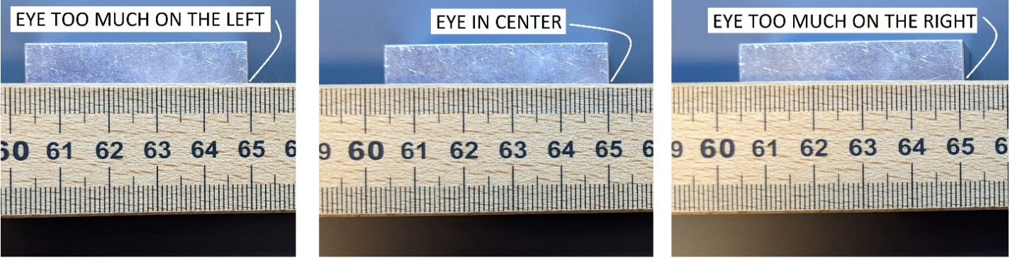

Figure 4: Parallax error when measuring the edge at 65 cm position.
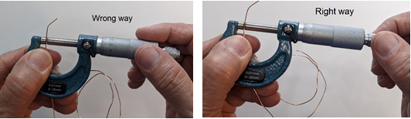

Figure 5: Turn the spindle by using the rachet.
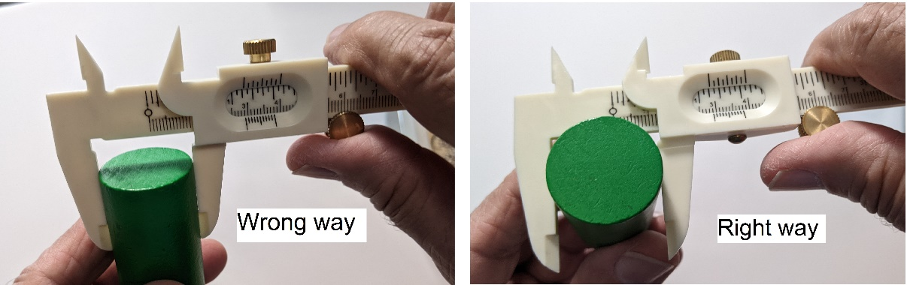

Figure 6: Right and wrong way to measure cylinder diameter
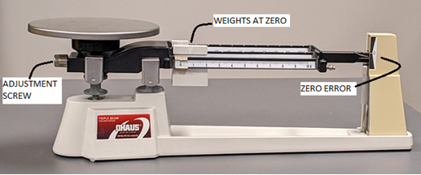

Figure 7: This balance has is a zero error which can be removed by rotating the Adjustment Screw.

2.8 IC-02: Measurements of Mass, Volume, and Density REPORT FORM

Date: _______________
Item number from figure in “Equipment”

Cylinder-1: _____ Cylinder-2: _____ Cylinder-3: ________

Rectangular Solid: ______ Irregular Solid: ________

Part I. Length and Diameter of Regular Solids with Vernier Caliper
 | 1 | 2 | 3 | 4 | Average | Average – Zero Error
Zero Error |  |  |  |  |  | X
Length of Cylinder-1
Length of Cylinder-2
Length of Cylinder-3
Diameter of Cylinder-1
Diameter of Cylinder-2
Diameter of Cylinder-3
Length of Rectangular Solid
Width of Rectangular Solid
Height of Rectangular Solid

Part II. Dimensions of Copper Wire with the Micrometer and Meter Stick
 | 1 | 2 | 3 | 4 | Average
Zero reading of Micrometer |  |  |  |  | X
Diameter Reading with micrometer |  |  |  |  | X
Diameter of wire (=reading – zero error)
Length of copper wire with metric ruler

Part III. Measurements of Mass
 | 1 | 2 | 3 | 4 | Average | Average – Zero Error
Zero error of triple beam balance |  |  |  |  |  | X
Mass of Cylinder-1
Mass of Cylinder-2
Mass of Cylinder-3
Mass of Rectangular solid
Mass of irregular Object
Mass of copper wire with
Electronic balance

Part IV: Determination of Volume of Irregular Solid using Overflow Can
 | 1 | 2 | 3 | 4
Level before immersion
Level after immersion |  |  |  |  | Average Volume
Volume of solid

Part V. Calculation of Density
Object | Mass  g | Length cm | Radius  cm | Volume  cm³ | Computed  Density  g/cm³ | Material of object | Accepted  Density  g/cm³ | Percent error in density
Cylinder-1
Cylinder-2
Cylinder-3
Rect. Solid |  | x | x
Copper Wire
Irregular Solid |  | x | x

2.9 TABLE OF RESULTS

Object | Item number in picture | Computed  Density | Material of object | Accepted  Density | Percent error in density
Cylinder-1
Cylinder-2
Cylinder-3
Rectangular Solid
Copper wire
Irregular Solid

2.10 REPORT SUBMISSION
Upload the following in the Report for this Lab:
 |  | Points in report
 | Text of Report: Table of Contents, Objectives, Equipment, Theory, Procedure.  DO NOT copy the Theory or Procedure from the manual. DO NOT tell the reader what to do. Write correct page numbers. | 10
 | The filled up “Report Form”. Make sure to include units of measurements.  Write correct Units. | 15
 | Sample Calculations  Do not make calculation error, rounding error | 5
 | Table of Results  Do not write too many or too few Significant Figures. Include Units. | 5
 | Take a photograph of the objects that you have actually used and attach it. Label the objects based on the picture in “Equipment”. | 5
 | Sources of Error (make a list) | 5
 | Discussion of the Results of this experiment. Include discussion of the possible errors that may have been made.  Any result that has >25% error from the expected values needs to be explained. | 10
 | Total | 55

2.11 ADDITIONAL INFORMATION
How to use a Vernier caliper:
2.42 min https://www.youtube.com/watch?v=FNdkYIVJ3Vc
5.04 min https://www.youtube.com/watch?v=4hlNi0jdoeQ
How to use a micrometer
4.50 min https://www.youtube.com/watch?v=oHqaLMEHlnE
5.11 min https://www.youtube.com/watch?v=i_jygJkJujE
Inside a Micrometer
3.57 min https://www.youtube.com/watch?v=cXU__cf1Xlk

2.12 POINTS TO THINK ABOUT (no need to answer these in the report)
- Why is each measurement taken more than once?
- Why was micrometer used instead of Vernier caliper for measuring the diameter of the wire?
- What is the “least count” of the measuring devices used?
- How can you get the density of an irregular shaped object?
- Was the cross-section of the wire circular?
- What is the effect of kinks in the wire?
- Why is electronic balance used for the wire, but not for the cylinders?
- Can you identify the material by knowing the density and appearance?
- How tight should the micrometer and Vernier be made while making measurements?
- What are the equations for volume of a cylinder, cube and sphere?
- How would you calculate the mass of an object if its density is known?
- To how many decimal places in cm can the Vernier and micrometer read?
- To what place of decimal (in grams) can the triple beam balance read?
- What range of errors are “acceptable”?
- What are the most likely errors that you may have made, or could have made?
- Anything in the results that is unusual or unexpected.
- How can some procedure or equipment be improved?

2.13 SAMPLE DATA

Date: _______________

Part I. Length and Diameter of Regular Solids with Vernier Caliper
 | 1 | 2 | 3 | 4 | Average | Average – Zero Error
 | cm | cm | cm | cm | cm | cm
Zero Error | 0.02 | 0.01 | 0.00 | 0.01 | 0.01 | X
Length of cylinder-1 | 6.30 | 6.31 | 6.31 | 6.28 | 6.30 | 6.29
Diameter of cylinder-1 | 1.45 | 1.46 | 1.45 | 1.44 | 1.45 | 1.44

Part II. Dimensions of Copper Wire with the Micrometer and Meter Stick
 | 1 | 2 | 3 | 4 | Average
Zero reading of Micrometer (mm) | 0.02 | 0.03 | 0.02 | 0.04 | X
Diameter Reading with micrometer (mm) | 0.60 | 0.62 | 0.61 | 0.61 | X
Diameter of wire (mm)  (= reading – zero error) | 0.58 | 0.59 | 0.59 | 0.57 | 0.58
Length of copper wire with metric ruler (cm) | 31.4 | 31.6 | 31.2 | 31.4 | 31.4

Part III. Measurements of Mass
 | 1 | 2 | 3 | 4 | Average | Average – Zero Error
Zero error of triple beam balance (g) | 0.00 | 0.01 | 0.00 | 0.00 | 0.00 | X
Mass of cylinder-1 (g) | 83.3 | 83.4 | 83.3 | 83.2 | 83.3 | 83.3

Part IV: Determination of Volume of Irregular Solid using Overflow Can
 | 1 | 2 | 3 | 4
Level before immersion (mL) | 34.3 | 67.2 | 42.9 | 52.1
Level after immersion (mL) | 74.8 | 107.3 | 83.2 | 92.8 | Average Volume
Volume of solid (mL) | 40.5 | 40.1 | 40.3 | 40.7 | 40.4

Part V. Calculation of Density
Object | Mass  g | Length cm | Radius  cm | Volume  cm³ | Computed  Density  g/cm³ | Material of object | Accepted  Density  g/cm³ | Percent error in density
Cylinder-1 | 83.3 | 6.29 | 0.72 | 10.244 | 8.13 | zinc | 7.13 | 14
Copper Wire
Irregular Solid |  | x | x

Calculations:
V = π r² h = π (0.72)² (6.29) = 10.244 cm³ ρ = M / V = 83.3 / 10.244 = 8.13 g/cm³

TABLE OF RESULTS

Object | Item number in picture | Computed  Density  g/cm³ | Material of object | Accepted  Density  g/cm³ | Percent error in density
Cylinder-1 | 12 | 8.13 | zinc | 7.13 | 14
Copper wire
Irregular Solid

